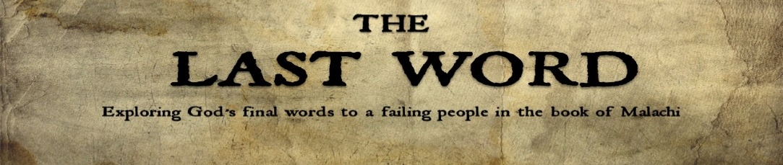
A Warning to Rogue Representatives
Malachi 2:1-9

Theme of Malachi – God’s call for His people to genuinely love,
fearfully worship and joyfully hope in His name.

THE COMMAND TO ROGUE REPRESENTATIVES

“Listen, you priests—this command is for you! 2 Listen to me
and make up your minds to honor my name,” says the Lord of
Heaven’s Armies, - Malachi 2:1–2 (NLT)

honor” - kabod = ________, _______ (many times translated “_______”)

CHARACTERISTICS OF ROGUE REPRESENTATIVES

1. They Don’t _________ to the Voice of Truth – 2:2

2. They Don’t ________ the ______________ of Truth – 2:6-7

3. They Don’t ________ a Life of Truth – 2:7-9

4. They Don’t ________ Others to Truth – 2:8

So we are Christ’s ambassadors; God is making his appeal through us. We speak for Christ when we plead, “Come back to God!” 21 For God made Christ, who never sinned, to be the offering for our sin, so that we could be made right with God through Christ. - 2 Corinthians 5:20–21 (NLT)

CONSEQUENCES FOR ROGUE REPRESTATIVES

1. Loss of ___________ and Being a __________ - 2:1-3

2. Negative Effects on ____________ - 2:3

3. ___________ and ___________ - 2:3-4

