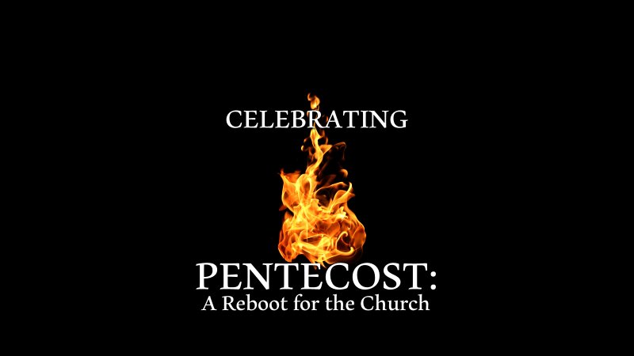

Acts 2:1-47

“Pentecost” – pentekoste = ________

Pentecost was another name for the Feast of Weeks and it was celebrated _____ days after Passover.

*Four reasons why Pentecost Sunday is significant for followers of Jesus and why this is an ideal day for a reboot of the church.

1. Pentecost Sunday was the _______ of the Church – Acts 2:41-42

• As we reboot let’s celebrate the church ____________.

2. Pentecost Sunday was the Launch of the __________ of the
Church – Matt. 28:19-20; Acts 1:8

• As we reboot let’s recommit ourselves to the great ________ we
have been given.

3. Pentecost Sunday was the Beginning of the _______ Days –
Acts 1:11; 2:16-17

• As we reboot let the reality that we are living in the last days
motivate us in our __________ and in our _________.

4. Pentecost Sunday was the Beginning of a New Ministry
of the ______ _______ – Acts 2:1-14; Ephesians 5:18

• As we reboot the church let’s seek to be Holy Spirit _______
followers of Jesus.

